LOMONOSOV MOSCOW STATE UNIVERSITY
FACULTY OF GLOBAL STUDIES
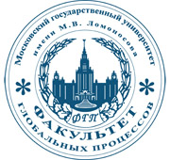

20-25 October, 2015
INTERNATIONAL SCIENTIFIC CONGRESS
«GLOBALISTICS – 2015»
Global Diplomacy in Unstable World
world

CALL FOR PAPERS

On October 20-25, 2015 the Faculty of Global Studies of Lomonosov Moscow State University will host an International Scientific Congress ‘Globalistics-2015’ in order to gather famous and reknown experts and scholars in the field of global and international studies, political and social sciences to discuss the most important and complicated global issues and trends. The Congress is dedicated to 70-year anniversary of the United Nations. The United Nations is an international organization founded in 1945 after the Second World War by 51 countries committed to maintaining international peace and security, developing friendly relations among nations and promoting social progress, better living standards and human rights.
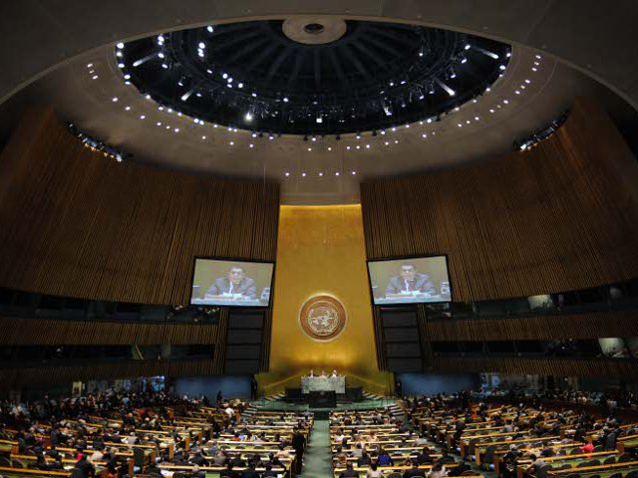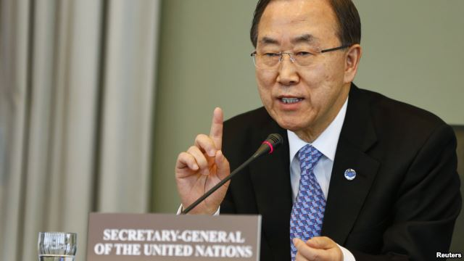

The Congress is held under the auspices of UNESCO. The main goal of this summit is to share professional experience and further maintain international cooperation in the sphere of promoting global studies and global science. The Chairman of the Organizing Committee is a rector of Lomonosov Moscow State University, academician Victor A. Sadovnichy.
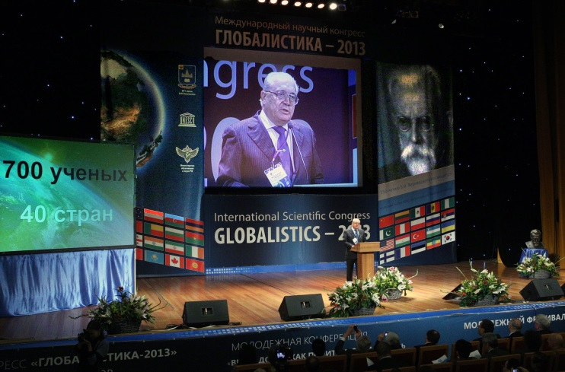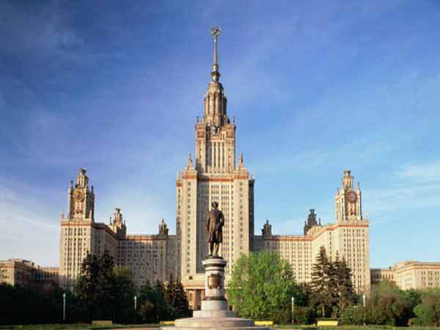

KEY SPEAKERS OF THE PREVIOUS GLOBALISTICS CONGRESSES
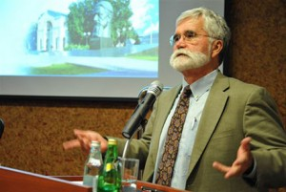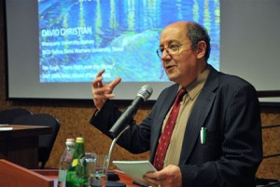
William Thompson, Indiana University (USA);
David Christian, Big History Association (USA, Australia);

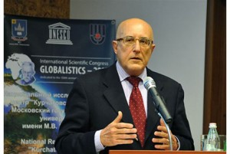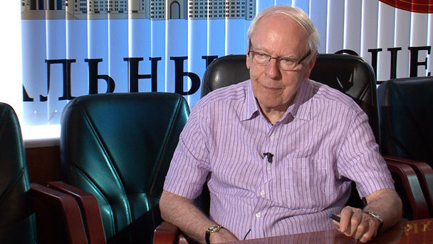

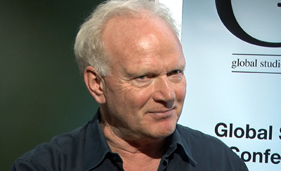

Fulvio Attina, University of Catania (Italy)
Roland Robertson, University of Aberdeen (United Kingdom)
Ulrich Beck, University of Munich (Germany)

Geography of the Congress

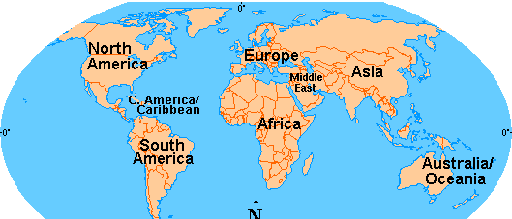

More than 500 scientists and specialists from 50 countries

Preliminary Program:
20 October – Arrival of Participants
21 October – Arrival of Participants
22 October - Opening Ceremony, 1st Working Day (Plenary Session and Workshops)
23 October – 2nd Working Day, Closing Session
24 October – Cultural Program
25 October – Departure of Participants
More detailed information will be available in the Information Letter. It will also be available at: http://www.fgp.msu.ru, http://globalstudies.ru

The program of the International Scientific Congress
"Globalistics - 2015: Global diplomacy in unstable
world "
October 20-25, 2015, Moscow State University

October 21
10.00-11.00 | Registration of the participants | The foyer of the assembly hall of the Fundamental Library of MSU (ICFL)  1st floor
11.00-14.00 | The opening ceremony of the Congress | Assembly Hall ICFL MSU, 1st floor
14.00-15.00 | Coffee-break
15.00-17.00 | Plenary session of the Congress | Assembly Hall ICFL MSU, 1st floor

October 22
10.00-14.00 | Workshops of the Congress | Convertible hall ICFL MSU, 1st floor
14.00-15.00 | Lunch Time
14.00-17.30 | Workshops of the Congress | Convertible hall ICFL MSU, 1st floor

October 23
10.00-14.00 | Workshops of the Congress | Convertible hall ICFL MSU, 1st floor
10.00-14.00 | Workshops of the Congress | The House of Culture Hall of the Moscow State University
14.00-15.00 | Lunch Time
16.00-19.00 | Summing up and closing ceremony of the Congress | The House of Culture Hall, MSU, 1st floor

October 24
The excursion program for non-resident and foreign participants

THEMES

SPECIAL THEME:
«Global Diplomacy in Unstable World»

Theme 1: Economy  - Global Markets  - Patterns of Global Investment  - Engines of Growth in the Developing World  - Global Financial Flows and Institutions  - EU Crisis and Perspectives  - Global Energy and Green Economy | Theme 2: Power AND POLITICS  - Imperialism and neo-colonialism  - ‘Soft power’ and the structures of hegemony  - Social movements  - Global Governance  - UN’s Role in International Relations  - New global axes  - Flashpoints of social conflict  - Welfare in a global context  - Security issues | Theme 3: SOCIETY AND Culture  - Nationalism and post-nationalism  - Diaspora  - Cosmopolitanism  - Cultural Globalization  - Hybridization
Theme 4: Environment
- Resources
- Agriculture
- Climate change
- Limits to Growth
- Global Ecology

_____________________________________________________________________________

We would ask all those who do not exclude the possibility of their taking part in GLOBALISTICS Congress to send us titles of their possible papers and a short abstract of your presentation by August 15, 2015:
Email: rozanov@fgp.msu.ru, congress2015@fgp.msu.ru

Contact person: prof. Alexander Rozanov, Vice-Dean, Head of International Department, Faculty of Global Studies, MSU.

Working languages:
Working languages of the Conference will be English and Russian. Simultaneous translation will be provided during the Conference on the 22nd and 23rd of October.

Selection of abstracts:

Selection of presentations will be made by the Organizing Committee and will be based on abstracts invited from the participants. Full papers are optional.
Abstracts should include:
- Title of the paper;
- Name of the author(s), name of the Institution with full address, phone/fax/e-mail;
- Background and purpose of the research;
- Data and methods which were used;
- Main results.

Abstracts should not exceed 2-4 pages (Format: Word, 14 font,
1.0 spacing). Full papers should be up to 10 pages. Abstracts and full papers will be published in the Conference Book. The Organizing Committee
will not translate the texts of abstracts and papers – they will be published in the original language as submitted by the authors.

Deadlines and dates:
Please note that deadlines are renewed!
Application for participation with abstracts / full papers – before 15 August 2015
Application for participation without presentation/report – until 01 October 2015
Selection of abstracts / full papers for the conference program – 20 August 2015
Book of abstracts / full papers will be published by the start of the conference.

Application & registration:
Participants are encouraged to apply for their participation before 15 August 2015 if with a paper/presentation, and before 01 October 2015 if without paper/presentation, by sending completed Application Form (please refer below) to the Organizing Committee: rozanov@fgp.msu.ru, congress2015@fgp.msu.ru.
No registration fee is needed.
Organizers will provide invitation letters for visa purposes, but do not typically aid, administratively or financially, in the procurement of visas.
Travel expenses are on the participants’ account.
Reception dinner and coffee-breaks will be provided by the Organizing Committee (Lomonosov MSU).

Organizing Committee Contact Information:
Address: 119991, Moscow, GSP-1, Moscow State University, Lenin Hills, 1, b. 51, 1-st campus of humanitarian faculties, the Faculty of Global Studies, Rooms 1163,1165.
Phone: (7495) 939-43-23
E-mail address: rozanov@fgp.msu.ru. congress2015@fgp.msu.ru
Website: http://www.fgp.msu.ru, http://globalistics.org

APPLICATION FORM
(Moscow, MSU, Congress 20–25, 2015)
Family name, first name

Degree, position

Association/Center/Consortium/Society

Number of delegates from
Association/Center/Consortium/Society
Office address

Title of the presentation

Form of participation
(oral presentation, publication without speech)

Accommodation: length of stay
Tel./fax.

E-mail

Visa Information
Only citizens of former CIS Republics, except for Georgia and Turkmenistan, may enter Russia with their national passports.
ALL OTHER TRAVELERS ARE REQUIRED TO HAVE A VISA.
Please see http://www.russianvisa.org/faq.html for more details.
REGARDING TYPES OF VISAS:
A TOURIST Visa is available for stays in Russia of less than two weeks time. A voucher letter for this type of visa is available through registered Russian hotels or tourist agencies where tourists are planning to stay and plan tours, respectively. Typically, payment for one hotel night is required before the hotel will issue a visa letter to a local embassy.
A BUSINESS Visa is valid for 12 months. In order to obtain a Business visa, an invitation must be filed (in this case, by Moscow State University), sent to the Russian Foreign Ministry, officially prepared, and mailed via DHL to a local embassy. This process typically takes 30-40 days.
Most visas will only be prepared within 45 days of entry into the country.
FOR VISA QUESTIONS AND SUPPORT:
Embassy of the Russian Federation to the USA: http://www.russianembassy.org/Embassy_eng/Consulate/tourist_visa.html
Visa Services:
Perry International: http://perryvisa.com/
TraVisa Outsourcing: https://russiavisa.travisaoutsourcing.com/russia/homepage
PVS International: http://www.pvsinternational.org/

HOST
Lomonosov Moscow State University
FACULTY OF GLOBAL STUDIES
Dean: Ilya V.Ilin, professor, Doctor of Political Science.
Dean’s Office tel.: +7 495- 939-43-23
Fax: +7-495-939-45-01
Web-site: www.fgp.msu.ru
Faculty of Global Studies was founded in 2005. The faculty specializes in preparing highly qualified specialists in the field of international relations and various aspects of Global Studies – an interdisciplinary scientific knowledge on globalization and global issues that integrates approaches and methods of humanitarian and natural sciences.
The educational program is implemented in accordance with an educational standard of Lomonosov Moscow State University in "International Relations".
Qualifications – Bachelor and Master of International Relations with in-depth knowledge of foreign languages
The faculty includes 4 Chairs: Chair of Globalistics, Chair of Geopolitics, UNESCO Chair on Global Problems and Chair of Global Social Processes.

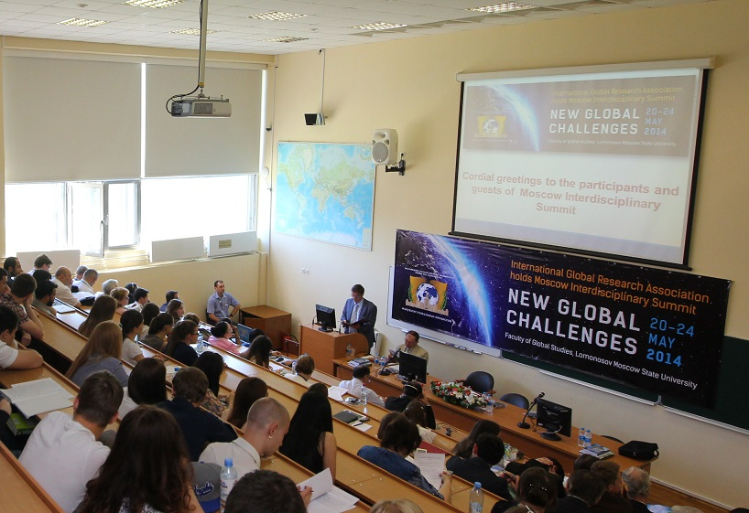

Conference Venue Map
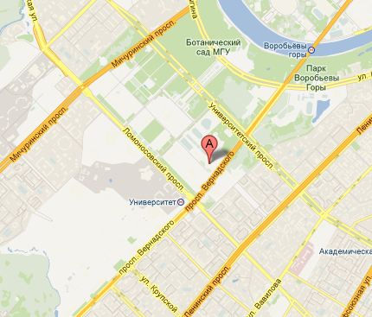

Moscow State University Campus Map

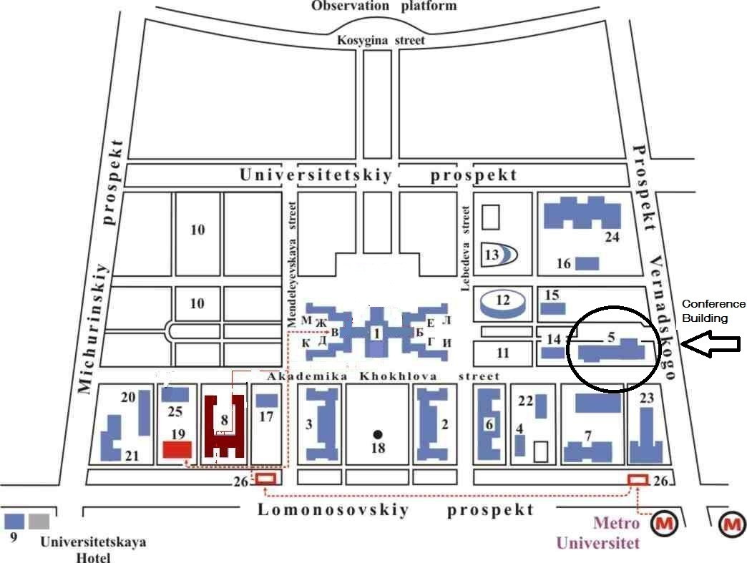

Transportation
Moscow Metro
Closest station to Moscow State University (7-10 minute walk) is the Universitet (Университе́т)Station on Vorob’evy Gory (Воробьёвы горы). You will also find a .pdf map of the Moscow Metro system here.
